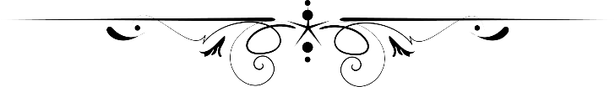

**Assignment**

**Comsats university Islamabad,Lahore Campus**

***Topic :***

**Console of**

**project**

Submitted by:

Umair Khalid, Hasham Aziz,Huzaifa

Roll no:

SP24-BSE-119,041,047

Submitted to

Sir Shahid Bhatti

Date

12 Dec 2024

This is homepage of our app



